Product Requirements Document Auditability & In-Tenant Observability for RACKAI Platform

Table of Contents
1. Vision 2
2. Problem Statement 2
3. Product Principles 3
4. Scope 4
In Scope 4
Out of Scope 4
5. Core Entities 4
Audit Event 5
Observability Metric 5
Log Entry 5
Trace 5
Tenant / Project / Workload 5
6. Observability Model 6
6.1 Real-Time Visibility 6
6.2 Historical Insights 6
6.3 Dimensions 6
7.Observability Data Flow 6
8. Correlation & Context Model 8
9. Audit Logging Model 8
Event Types 8
Dataset Audit Events 9
10. Integration with Platform Systems 9
RBAC 9
Metering 9
Quotas 9
Billing 9
11. Request Observability Flow 9
12. API Access 10
13. Data Retention & Compliance 11
14. Failure Handling 11
15. Success Criteria 11
15. Summary 11
Operational Impact 12
Final Statement 12

Document Name | Auditability & In-Tenant Observability PRD
Version | v1.0
Status | Review
Author | Amine Badaoui
Date Created | 30/04/2026
Last Updated | 30/04/2026
Stakeholders | Product, Engineering
Reviewers

1. Vision
Provide tenants and platform operators with complete visibility and traceability of all actions, workloads, and system behavior across the RACKAI platform.
The system must enable:
- real-time monitoring of workloads and system activity
- historical traceability of all actions and decisions
- auditable records for compliance and governance
The system should make observability feel:
- transparent — users can see what is happening in real time
- traceable — every action can be explained and audited
- reliable — data is accurate and consistent
- tenant-isolated — no cross-tenant visibility

2. Problem Statement
As RACKAI scales across tenants, workloads, and users:
- users need visibility into:
  - workloads
  - usage
  - performance
- organizations require:
  - audit trails
  - compliance reporting
  - incident debugging
Without this system:
- actions cannot be traced back to users or workloads
- billing and usage cannot be verified
- security incidents are difficult to investigate
- compliance requirements cannot be met
- tenant trust in the platform decreases

3. Product Principles
- Full Traceability
Every action must be attributable to:
  - user or service identity
  - tenant and project
  - workload or resource
- Tenant Isolation
Observability and audit data must never leak across tenants
- Consistency Across Systems
Observability must align with:
  - RBAC decisions
  - metering records
  - quota enforcement
  - billing outputs
- Real-Time + Historical Visibility
Provide both:
  - live system insights
  - long-term audit records
- Immutable Audit Records
Audit logs must not be altered or deleted
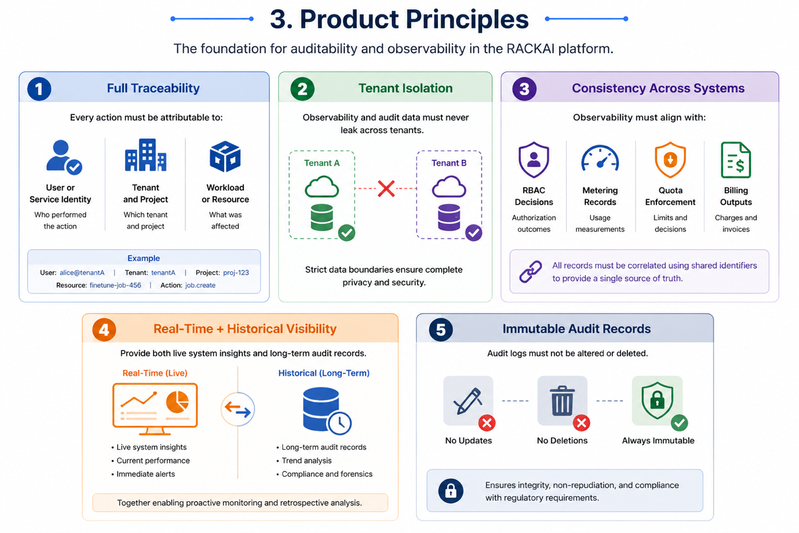

4. Scope

In Scope
- workload observability (inference + fine tuning)
- usage and performance monitoring
- audit logging (user + system actions)
- tenant-level dashboards
- API access to logs and metrics

Out of Scope
- external SIEM integration (future)

5. Core Entities

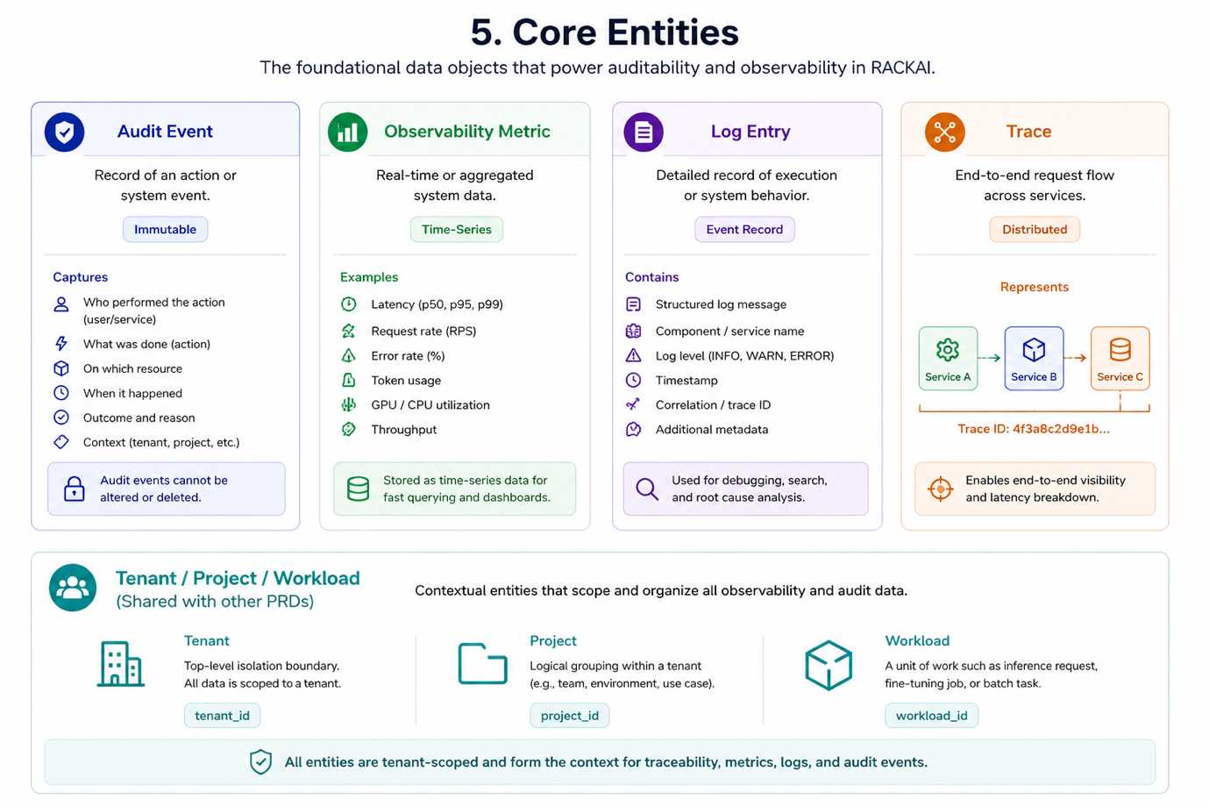

Audit Event
- record of an action or system event
- immutable

Observability Metric
- real-time or aggregated system data
- e.g., latency, tokens, errors

Log Entry
- detailed record of execution or system behavior

Trace
- end-to-end request flow across services

Tenant / Project / Workload
(shared with other PRDs)

6. Observability Model

6.1 Real-Time Visibility
Tenants must be able to see:
- active workloads
- request rates
- latency and performance
- error rates
- quota usage

6.2 Historical Insights
Tenants must be able to:
- view usage over time
- analyze cost trends
- review workload patterns
- investigate anomalies

6.3 Dimensions
Data must be filterable by:
- tenant
- project
- model
- workload
- time
6.4 Observability Consistency Model
- real-time metrics must be available with low latency
- audit logs may be eventually consistent
- missing or delayed logs must be detectable and recoverable

7.Observability Data Flow
Observability data is generated across multiple system components and must flow through a unified pipeline:
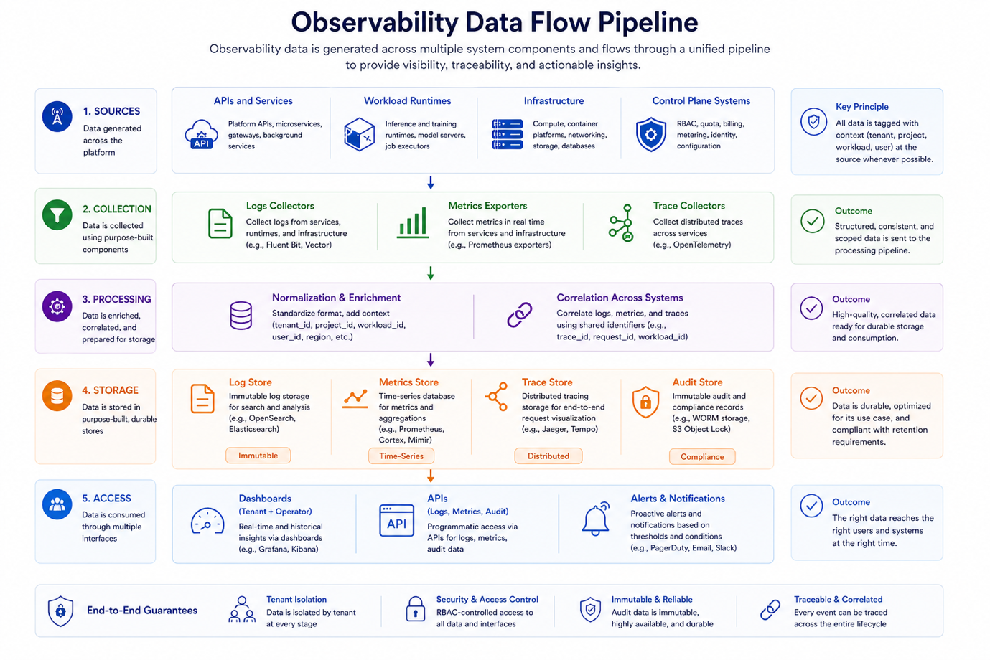
Sources:
- APIs and services
- workload runtimes (inference / training)
- infrastructure (compute, networking)
- control plane systems (RBAC, quota, billing)
Collection:
- logs collectors
- metrics exporters
- trace collectors
Processing:
- normalization and enrichment (tenant, project, workload context)
- correlation across systems
Storage:
- log store (immutable)
- metrics store (time-series)
- trace store (distributed tracing)
- audit store (compliance records)
Access:
- dashboards (tenant + operator)
- APIs (logs, metrics, audit)
- alerts and notifications

8. Correlation & Context Model
All observability and audit data must include shared identifiers to enable correlation:
  - tenant_id
  - project_id
  - workload_id
  - model_id
  - user/service identity
  - request_id (global correlation ID)
This enables:
  - end-to-end tracing of requests
  - linking RBAC decisions → execution → metering → billing
  - debugging and audit reconstruction

9. Audit Logging Model
Audit Events Must Capture:
- user or service identity
- tenant_id
- project_id
- resource (model, dataset, job, etc.)
- action (deploy, execute, view, etc.)
- timestamp
- result (success / failure)
- reason (if denied or failed)

Event Types
- authentication events
- RBAC authorization decisions
- workload execution events
- quota enforcement actions
- billing access
- configuration changes

Dataset Audit Events
- dataset uploaded (who, when)
- dataset accessed (which job)
- dataset attached to fine-tuning job
- dataset deleted

10. Integration with Platform Systems

RBAC
- logs all authorization decisions
- provides identity context

Metering
- provides usage records
- aligns with audit events

Quotas
- logs enforcement actions
- records throttling / rejection

Billing
- uses audit + usage for verification

11. Request Observability Flow
For each request:
- Request received
- Authentication event logged
- RBAC decision logged
- Quota decision logged
- Execution metrics captured
- Metering event generated
- Audit record finalized
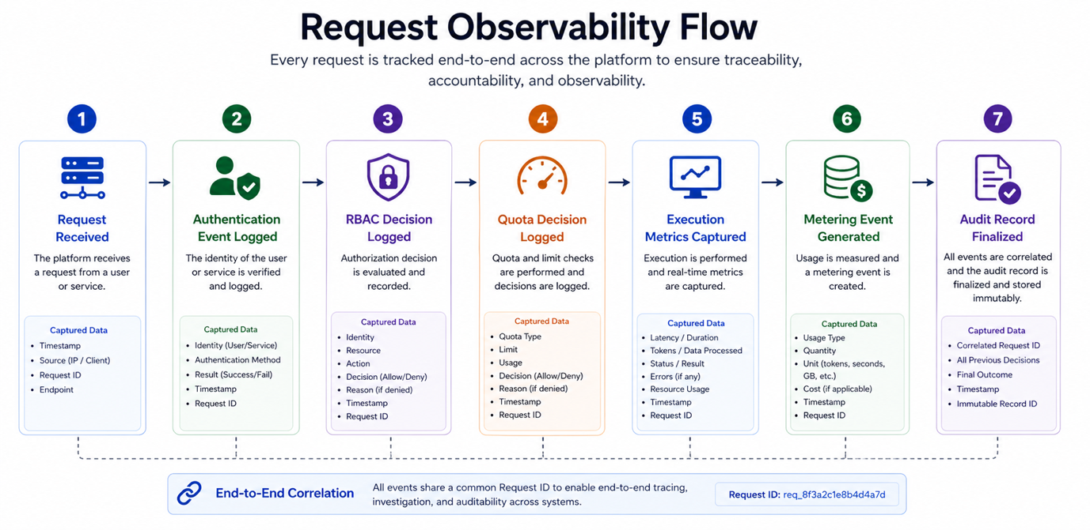
9. Alerting & Notifications
The system must support:
  - threshold-based alerts (latency, errors, quota usage)
  - anomaly detection (future)
  - tenant-level alerts
  - platform-level alerts
Alerts must be:
  - configurable
  - scoped to tenant or system
  - delivered via APIs or integrations

12. API Access
Observability and audit data must be accessible via APIs:
- logs API
- metrics API
- audit API

Security Requirements
- all logs, metrics, and audit data must be tenant-scoped
- access must be enforced via RBAC
- sensitive data (e.g., prompts, datasets) must be masked or restricted

13. Data Retention & Compliance
- audit logs must be retained for defined periods
- data must be query able for compliance audits
- logs must be immutable

14. Failure Handling
- logging failures must not block execution
- logs must be retried and eventually consistent
- missing audit data must be detectable

15. Success Criteria
- 100% of actions produce audit events
- zero cross-tenant visibility
- audit logs are immutable
- observability data is available in near real time

15. Summary
Auditability and observability provide the visibility and trust layer for the RACKAI platform, ensuring that all activity across tenants, workloads, and services is transparent, traceable, and verifiable.
They establish a unified view of system behavior, enabling both tenants and platform operators to understand what is happening in real time and to investigate what has happened historically.
They ensure:
- Every action is visible
All user and system activities—such as model deployments, inference requests, data access, and configuration changes—are captured and made observable through logs, metrics, and dashboards.
- Every decision is explainable
Critical system decisions, including:
  - RBAC authorization outcomes
  - quota enforcement actions
  - workload execution results
are recorded with sufficient context to clearly explain why a decision was made.
- Every workload is traceable
Each workload (inference or fine-tuning) can be tracked end-to-end across:
  - authentication
  - authorization
  - execution
  - metering
  - billing
providing a complete lifecycle view for debugging, auditing, and cost validation.

Operational Impact
With auditability and observability in place, the platform can:
- detect and diagnose issues quickly through real-time monitoring
- provide tenants with clear insight into performance, usage, and cost drivers
- support internal operations with reliable system health and debugging data
- validate billing and usage through traceable records
- meet enterprise security, governance, and regulatory requirements

Final Statement
This system ensures that:
everything that happens in the platform can be observed, explained, and proven
Every request, decision, and outcome is:
- observed through metrics and logs
- explained through contextual data and traceability
- proven through immutable audit records
Together, this enables RACKAI to operate as a:
transparent, debuggable, and compliance-ready AI platform—where trust is built through complete visibility and verifiable system behavior.

